Nepal College of Information Technology
Imadol, Lalitpur

Lab. 4

Area Filling: Boundary Fill

Introduction
Boundary fill approach paints a polygon recursively with a fill color and using either a 4 connected or 8 connected approach, moving outward from the seed pixel until the boundary has been reached or a pixel has been reached that has been repainted with the fill color. Applications of this algorithm can be seen in applications such as MSpaint, Photoshop where objects get filled using a bucket tool.

Objective
To understand the logic behind various area filling algorithms using the boundary and flood fill approach.

Algorithm

boundaryFill(int x,y,fill_color, boundary_color)  {  int color;  getpixel(x,y,color)  if(color != boundary_color AND color != fill_color )  {  setpixel( x,y,fill_color)  boundaryFill( x+1,y,fill_color, boundary_color)  boundaryFill( x,y+1,fill_color, boundary_color)  boundaryFill( x-1,y,fill_color, boundary_color)  boundaryFill( x,y-1,fill_color, boundary_color)  }  } | 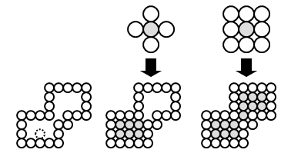

Start at a point inside a region and paint the interior outward toward the boundary.
If boundary is specified in a single color the fill algorithm proceeds outward pixel by pixel until the boundary color is encountered
Accepts as input coordinates of an interior point (x, y) a fill color and boundary color.
Starting from (x, y) the procedure tests neighboring position to determine whether they are of the boundary color.
If not they are painted with fill color and their neighbors are tested
Process continues until all pixels up to boundary color for the area have been tested

Tutorial:

i. What is the role of recursion used in this algorithm?
ii. Modify the above algorithm to implement the Flood Fill algorithm.

